La jábega, in 10 minutes

Hi everyone!
I am Felipe, and I would like to tell you about the jábega. A boat with a lot of history behind it. This is a typical boat on the Malaga coast, whose origin dates back to the dawn of time.
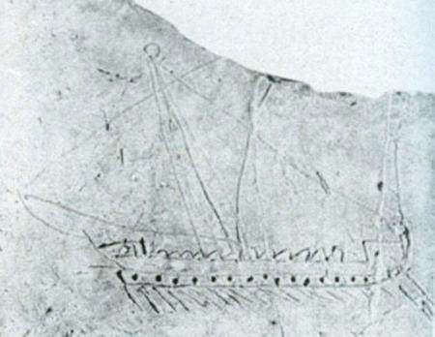Usually, it is said that its origin is Phoenician. Maybe. Probably.
Malaga’s history spans about 3000 years, and both the city and its port, in the middle of the bay, are one of the oldest in the world.
According to most researchers, the Phoenicians, as Malaka, founded it about 770 BC. In addition, there is an evidence of the presence of Phoenicians dromons, which is a kind of rowing boat, in this shores.
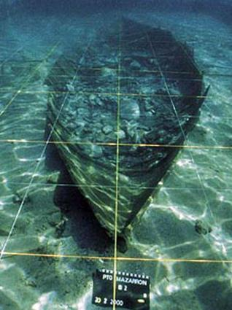For example, this painting of a Phoenician dromon has been found at the city centre.
Another evidence is a flotsam of a dromon, near Almería, with the same size of a jábega.
Several similarities point to an inheritance of the ancient dromons to the jábega:
For example, the peak in the bow, with a snake head. In Phoenician times, the ram, or in Spanish, the espolón, was used as a weapon to sink other boats.
And, also, the four wooden bitts, the vertical sticks in the bow, here called maniquetas. They were already present in ancient Egyptian boats, where it was used to operate with the nets and the ropes. This element is also found in some Whale boats
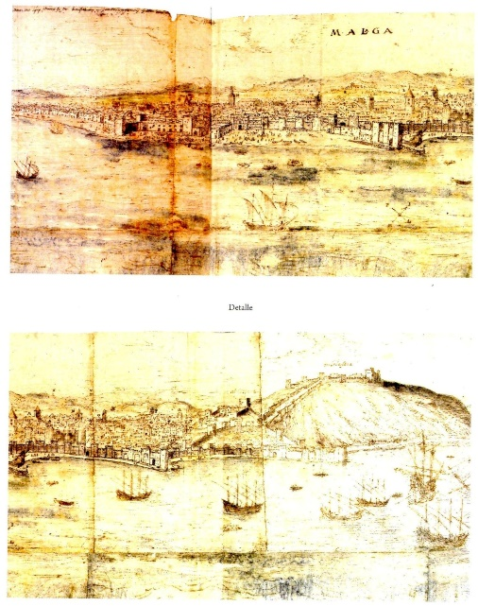
Finally, the stem (roda) in both the bow and the stern. This is an extension of the keel, and it is a typical part in byzantine dromons, which are a direct heritage from Phoenicians boats.
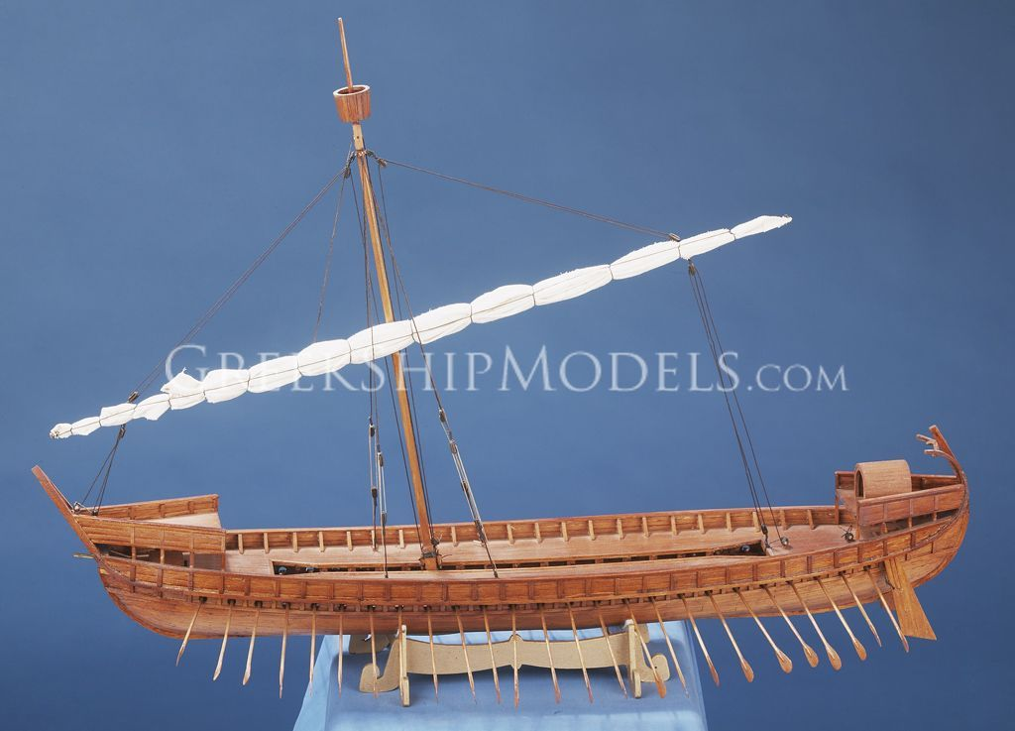If you compare the latest byzantine dromons in the twelfth century with the first jábega boats in pictures from the sixteenth century, like this one, it seems very difficult to deny the link between them. The sail was recently eliminated, but it was present in some jábegas until a few years ago.
Other parts of the boat are the rowlocks, named here as escálamo.
And, instead of the rudder, we have an special oar called Espaílla, which gives the name to our club.
Probably, you know that the sides of a ship are called the port and starboard. But, what you probably didn't know is that the starboard name came from steering board, estribor in Spanish, because of the “steering row”, la espadilla, which is, obviously, in the right side of the pilot. The port board is in the opposite, and that side of the boat, placed close to the dock, was used to go up or leave the boat. We keep that custom in our jábegas. And what behind the name, jábega? In fact, the real name of the boat is barca de jábega, boat of jábega, as this is the name of the fishing art used here.
The name came from the times of the Muslim occupancy of Andalusia. Xabeq is probably the original name, dated about the 13th century.
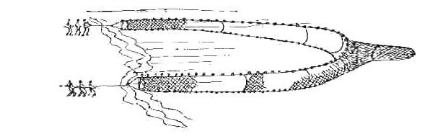The jábega is a net with a conic shape, which is extended, using the boat, forming an arc of about one kilometre length.
After laying the net, using the boat, the rowers, called here the jabegotes, pull the net back to the shore using an ancient instrument called the traya.
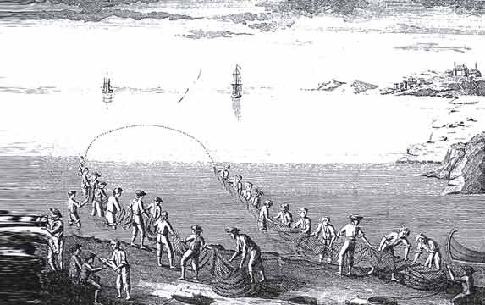In present, this kind of fishing art is forbidden, due to the huge amount of young fishes captured by using this technique. But, eventually, we repeat this "ceremony", but only for cultural and ethnological reasons, as you can see in the video link I sent you.
https://vimeo.com/744955800
For example, we will repeat it in two weeks. Of course, after finishing, we freed the fishes.
Probably due to the prohibition of the fishing art, and because of the appearance of new motor boats for fishing, the jábegas started to disappear everywhere. At the beginning of the XX century, there were hundreds of jábegas. From Almería to Huelva. Along 500 hundred kilometres.
In the other hand, 20 years ago, there were no more than ten jábegas, and all of them in just a 5 kilometres shore, from Rincón de la Victoria to Málaga.
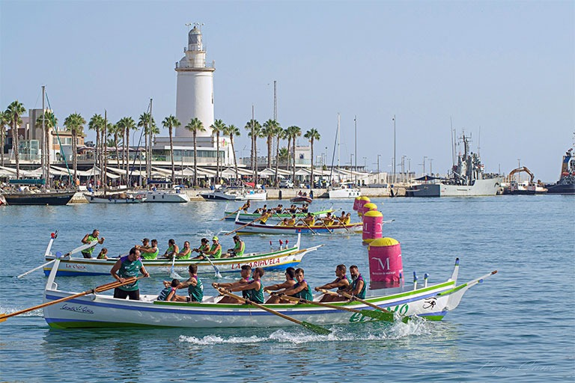But, occasionally, a small group of rowers, to which our boss, Agustin, belonged, kept another tradition with the boats: the summer races between them. In addition, due to the competition, the jábegas arise as phoenix from the ashes. And, I think, it's important to say that our club was a pioneer in this reborn of the jábega.
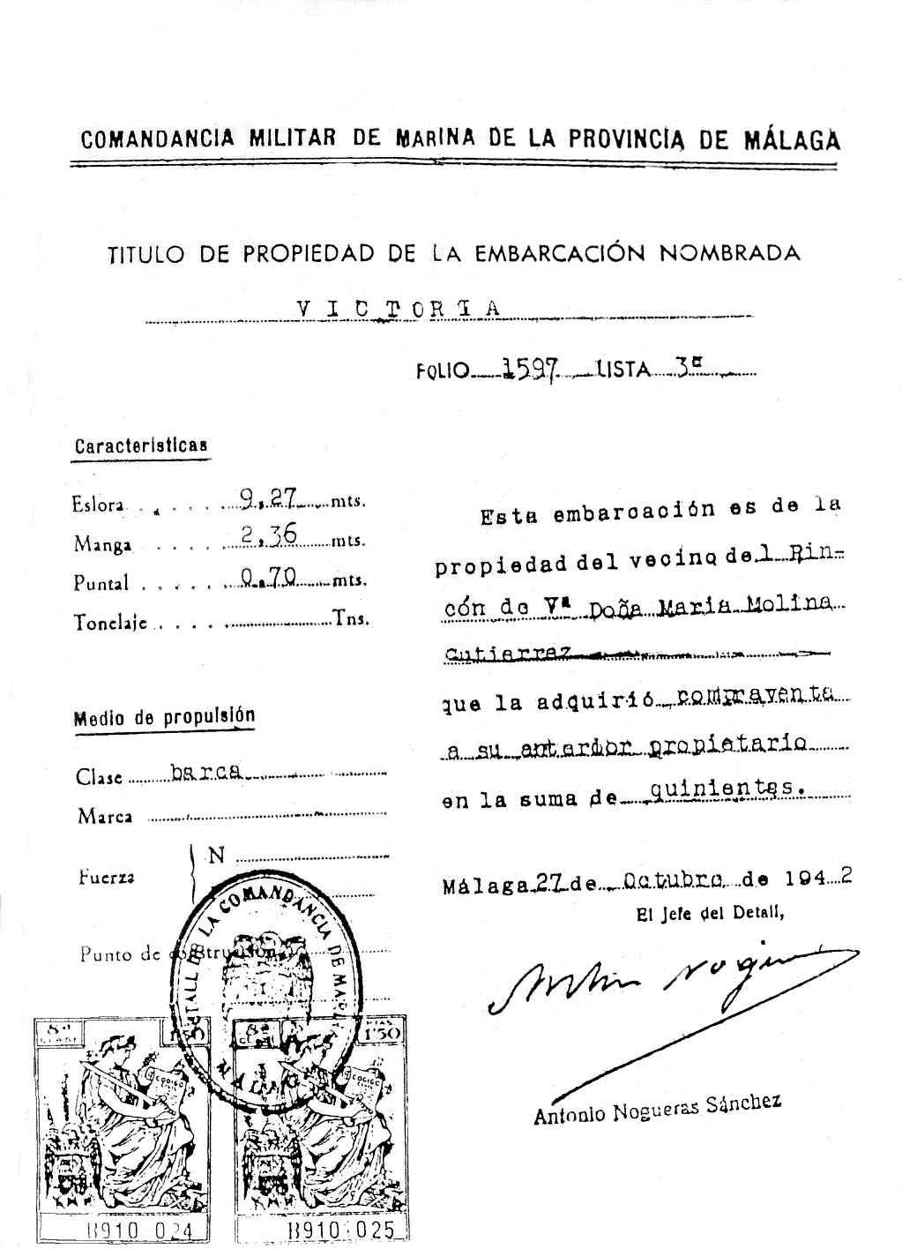Nowadays, there are ten clubs for traditional rowing and the number of jábegas duplicated in ten years thanks to the sport use of it.
You can see here the oldest existing jábega, la Victoria, a boat from nineteen forty, which, joint to Santa Cristina and Araceli, are the latest members of a dying era.
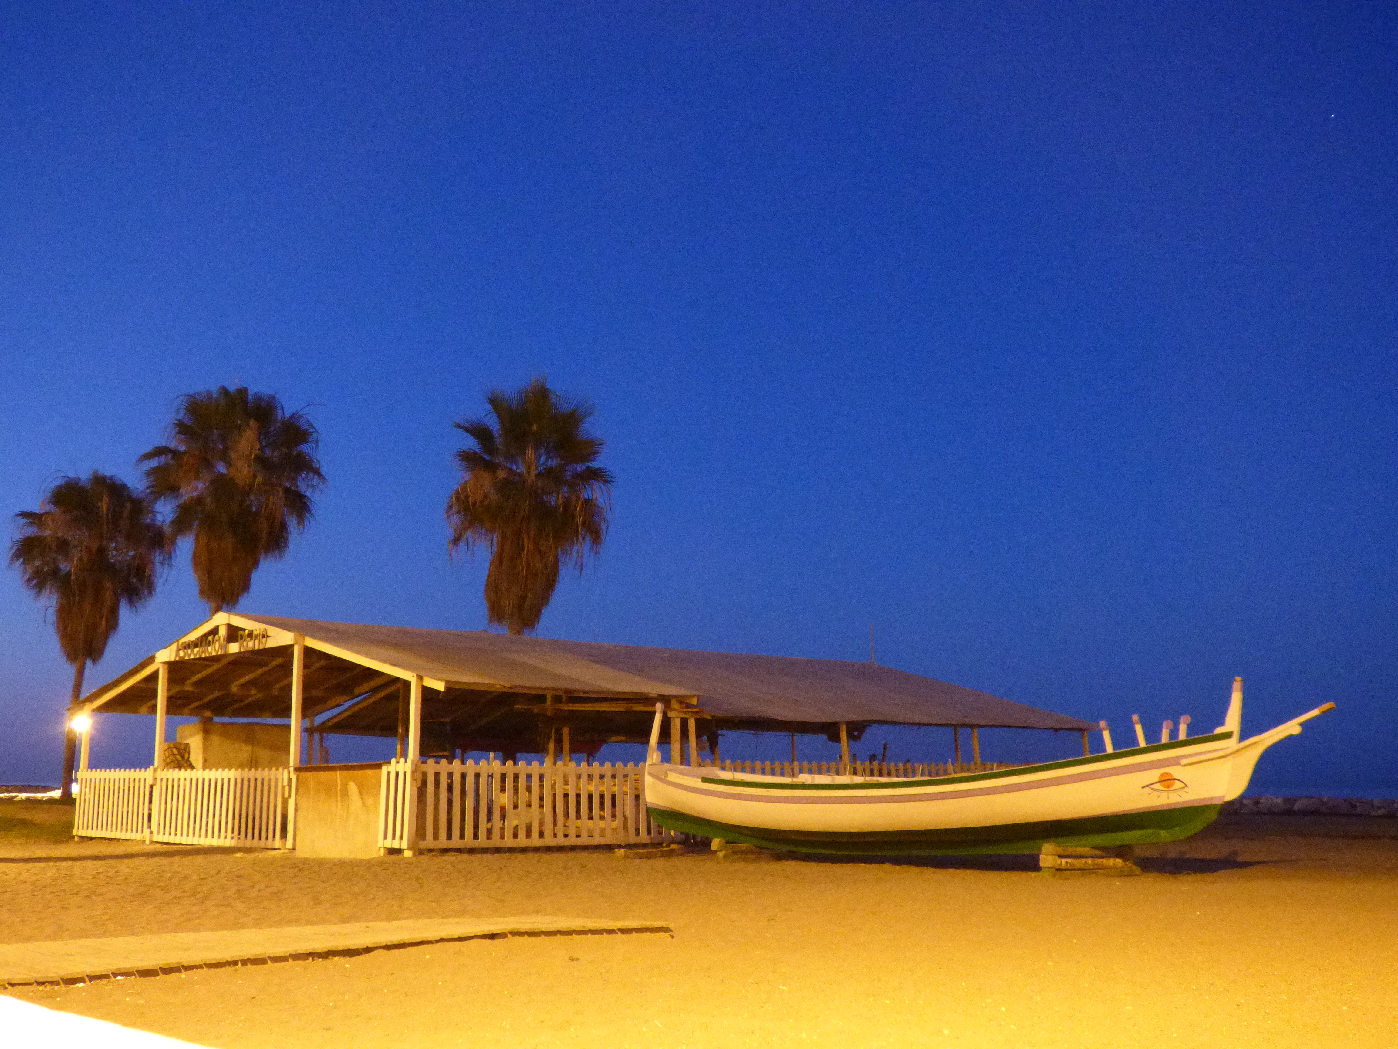In contrast, we have here the light and fast boat Carmen y Gloria, representing this new age for the jábega: a boat born for competition, but holding the tradition in its shape.
Now, it is time to know, from first hand, how the ancient Phoenicians bring the boat from the sand to the sea, using the parales, because nothing changes in thousands years...

Thank you so much

